Aug 6 2012
Bonnie Renfro updated the Board on the proposed “mega site” in Liberty, which would potentially attract a significant manufacturing company such as an auto or aviation business. She provided the following information:
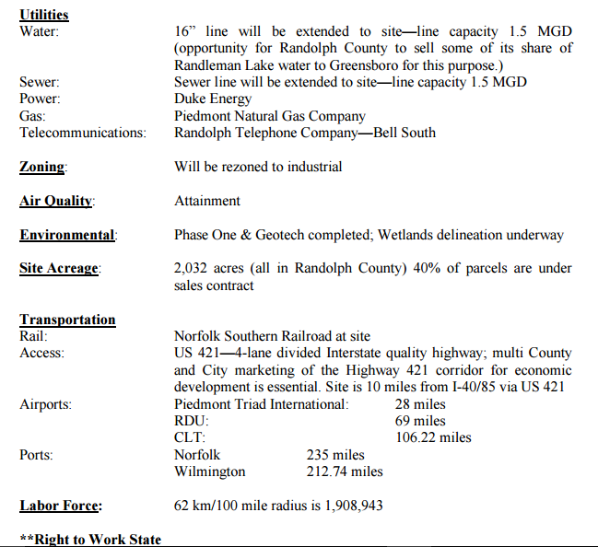
Ms. Renfro said that $5 million has been appropriated for this project from the State of North Carolina under the purview of Department of Commerce Secretary Keith Crisco. She urged the Board to start thinking about revenue sharing options and inter-local agreements with other participating local governments. Ms. Renfro mentioned that the City of Burlington and Alamance County have expressed interest in any revenue sharing opportunities. She also mentioned that there was a group of property owners who appear to have organized in opposition to the project.
Jan 7 2013
Assistant County Manager/Finance Officer Will Massie reported that former Governor Perdue, in her final days in office, decided that the $5 Million grant from the Department of Commerce that the State had set aside in its budget for Randolph County to utilize for the Liberty mega site, should not go to Randolph County alone. Rather, requests for proposals were distributed to 11 local governments seeking their applications for a portion of the grant. Seven governments responded with their applications and three were awarded with equal $1,666,666 grants. Randolph County was one of the recipients. Mr. Massie said that no matching funds from the County are required. The grant is to be used for site development at the Liberty mega site. County Manager Richard Wells said that 637 acres of land located at the proposed Liberty mega site has been offered to ALPATH LLC (the limited partnership formed to oversee the development of the Liberty mega site) for $5.9 Million. The owner of the 637 acres, Dexter Blakely, is eager to sell and has offered a contract on the property with a $30,000 non-refundable deposit in which the acreage would be held for 12 months. Mr. Wells said that in addition, another 98.9 acres adjoining the Blakely property to the north, owned by Nancy Lindley and Ferment Lindley, is also available for $315,000. Mr. Wells recommended using the $1,666,666 grant to purchase the 98.9 acres and to make a deposit on the 637 acres as soon as possible. Mr. Wells said that he planned to meet with attorney David Joseph, who is a member of ALPATH, on Wednesday. Mr. Joseph has been heavily involved with negotiations of land acquisition for the mega site. After meeting with Mr. Joseph, Mr. Wells said that he would also meet with H.R. Gallimore, who has also been working on the project with Mr. Joseph, in order to proceed with the purchase of the properties, if agreeable with the Board.
Feb 4 2013
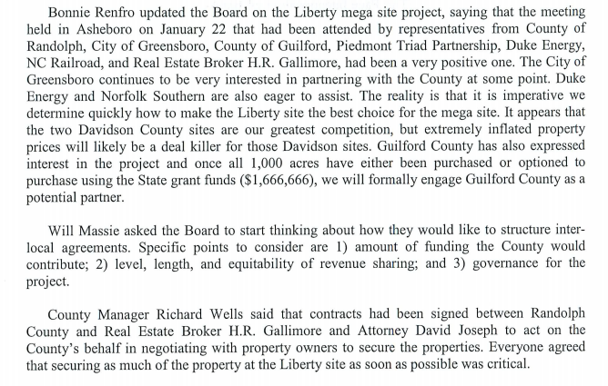
Apr 8 2013
At 8:12 p.m., the Board, already in closed session on another matter, began closed session on a different matter to establish, or to instruct the public body's staff or negotiating agents concerning the position to be taken by or on behalf of the public body in negotiating the price and other material terms of a contract or proposed contract for the acquisition of real property by purchase, option, exchange, or lease, pursuant to NCGS 143-318.11(a)(5)(i). Commissioners Holmes, Frye, Kemp, Lanier and Haywood were present. Also present were County Manager Richard Wells; Will Massie, Assistant County Manager/Finance Officer; Ben Morgan, County Attorney; Aimee Scotton, Associate County Attorney; Paxton Arthurs, Public Works Director; Cheryl Ivey, Clerk to the Board; and Bonnie Renfro, Randolph County EDC President. County Manager Richard Wells presented a map of the proposed mega site, which included the properties owned by Dexter Blakely and Nancy/Ferment Lindley. Mr. Blakely, who is the owner of a 637-acre tract, has offered the County a contract on the property at $10,300/acre, with a $50,000 non-refundable deposit in which the acreage would be held for 18 months. Mr. Wells said that in addition, another 98.9 acres adjoining the Blakely property to the north, owned by the Lindleys, is also available for $315,000. Mr. Wells said that securing the properties as soon as possible was critical because the state grant must be used within a year or it will be reverted to the state. He recommended using the $1,666,666 state grant to purchase the 98.9-acre tract and to make a deposit on the 637 acres as soon as possible. The Board agreed to proceed with the purchase of these properties and to hold public hearings on the matter at subsequent regular County Commissioners meetings, after which the Board will consider formal action.
Aug 5 2013
At 7:50 p.m., the Board, already in closed session on another matter, began closed session on a different matter to establish, or to instruct the public body's staff or negotiating agents concerning the position to be taken by or on behalf of the public body in negotiating the price and other material terms of a contract or proposed contract for the acquisition of real property by purchase, option, exchange, or lease, pursuant to NCGS 143-318.11(a)(5)(i) and to discuss matters related to the location or expansion of business in the area served by this body pursuant to NCGS 143-318.11(a)(4). Commissioners Holmes, Frye, Kemp, Lanier and Haywood were present. Also present were County Manager Richard Wells; Will Massie, Assistant County Manager/Finance Officer; Ben Morgan, County Attorney; Aimee Scotton, Associate County Attorney; Cheryl Ivey, Clerk to the Board; Amanda Varner, Deputy Clerk to the Board and Bonnie Renfro, Randolph County EDC President. Aimee Scotton provided some general information for the Commissioners, should they wish to proceed with securing the acquisition of property for the proposed Liberty mega site using the State grant money. For the property owned by Dexter Blakely, Ms. Scotton said that Mr. Blakely is aware that the idea of post-closing leases is not acceptable. He has indicated that he is still interested in selling and that he will have drafts of clean contracts (with no post-closing obligations) within the next 60 days. At that point, the new proposals can be considered. She also advised that Alpath has an option to purchase the Lindley property that will expire towards the end of this year. Ms. Scotton suggested that if the Board decides that it wants to move forward, once it has something definite to consider from Mr. Blakely, then there are a number of ways to structure the arrangement. She asked the Board to consider the level of direct control that the County wishes to maintain if we move forward, as that will determine how best to structure the purchase agreement and, ultimately, the ownership of the property. After discussion, the Board decided that there should be some discussion of this project in open session at the Board’s September meeting.
Oct 7 2013
Update on Greensboro/Liberty Mega Site Bonnie Renfro, Randolph County EDC President, said that at the Commissioners’ last meeting in early September, she heard two things: 1) a decision that the Board wished to seek to transfer the grant that Randolph County received from the state to the Randolph County Development Corporation, and 2) is the State willing to fiscally support this type of project? Ms. Renfro said that she contacted the State Department of Commerce the following day to ascertain what the process would be to transfer the grant. She learned that a letter of request from the County to the Secretary of Commerce would be needed. She has drafted that letter and has sent it to the County. The Board of the Randolph County Development Corporation, which is not the EDC, but a separate 501c3 board, established in 2004 for this type of purpose, has met and agreed to accept that grant and its responsibilities if the County chooses to pursue that and the State agrees to do so. However, Ms. Renfro said that the State said that we may want to hold off on sending the letter because there is a lot going on right now with the State as they restructure their Department of Commerce and many other things. They did not know if they would be able to get an answer in a timely way. Therefore, she said that we are ready to submit the letter at the appropriate time, which has not yet been determined. Regarding the other question: “Is the State willing to support this type of project?,” Ms. Renfro said that Secretary of Commerce Sharon Decker made an announcement in June that she understood that many communities across our state were seeking to create and promote large tracts of land suitable for a large scale development. She said the question (was the state willing to support that) had come up in discussions with clients and communities. Secretary Decker responded, “I don’t know the answer to that question, but I will find out.” Ms. Renfro said that Secretary Decker is in the midst of an exercise that involves the executive and the legislative branches to ascertain the answer to that question. But Ms. Renfro said she doesn’t believe any decision has been made at this point. Vice Chair Frye said that the governor was in Greensboro the previous week and received that question publicly. His answer was that the State would be behind an auto manufacturing facility in North Carolina, but he didn’t address any specific site. Approval of Letter of Support for Proposed Chatham/Randolph Mega-site Certification On motion of Lanier, seconded by Frye, the Board voted unanimously to approve a letter of support for the propos
At 7:40 p.m., the Board, already in closed session on another matter, began closed session on a different matter to discuss matters related to the location or expansion of business in the area served by this body pursuant to NCGS 143-318.11(a)(4). Commissioners Holmes, Frye, Kemp, Lanier and Haywood were present. Also present were County Manager Richard Wells; Will Massie, Assistant County Manager/Finance Officer; Ben Morgan, County Attorney; Aimee Scotton, Associate County Attorney; Cheryl Ivey, Clerk to the Board; Amanda Varner, Deputy Clerk to the Board and Bonnie Renfro, Randolph County EDC President. In a quick update regarding the proposed Greensboro Liberty mega site, Ms. Renfro told the Board these types of projects are highly competitive, requiring that communities and states have a site that is ready to go and who are willing to offer financial incentives that will offset both upfront and operational costs for a company. She said that in preparation for this type of opportunity, the State has asked that we identify all local government support for a mega site project based on some conservative assumptions about the economic impact of a potential project. Ms. Renfro provided a handout to Board members, which contains the following conservative project assumptions for their consideration, saying that a decision would be needed soon on the County’s desired participation, if any, in this project:
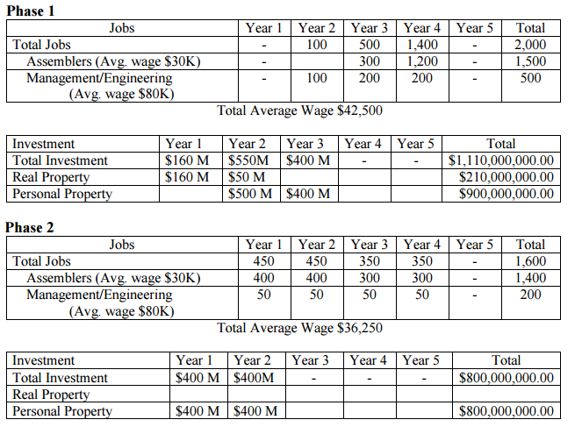
These assumptions are intended to be conservative estimates of job creation, average wages and capital investment based on past automotive projects and discussions with knowledgeable site selection experts. Note #2: In Phase 1, job creation does not begin until the second year due to the two-year construction time table of the facility. Note #3: It is anticipated that Phase 2 will begin in about four to five years after the initial announcement and there may be some overlap with Phase 1.
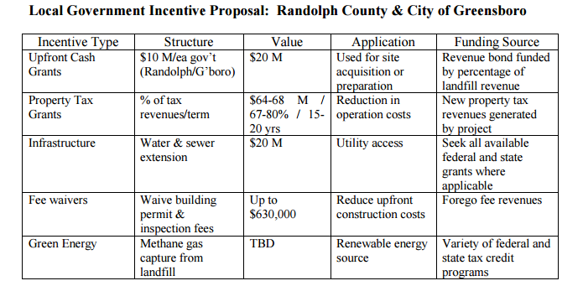 1. Assumes an inter-local agreement with Randolph County and Greensboro for cost and revenue sharing for site and project. 2. Water cost and source to be negotiated with Greensboro 3. Develop supplier and vendor recruitment incentive plan
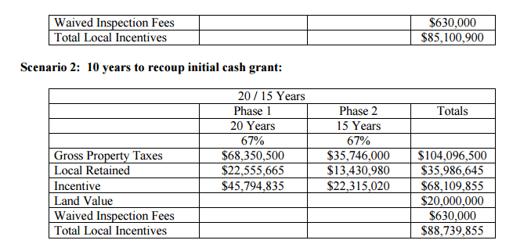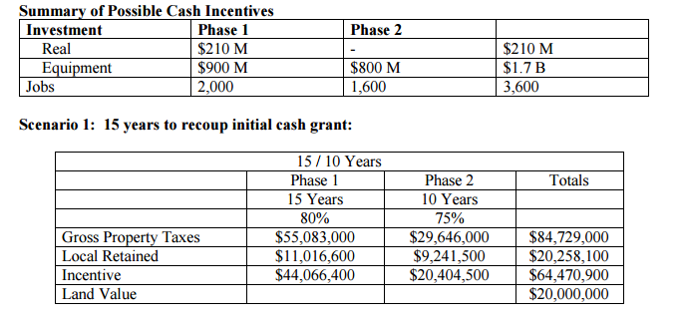
At 8:14 pm, on motion of Frye, seconded by Haywood, the Board voted unanimously to end closed session and to return to regular session.
Feb. 3, 2014
Ms. Renfro reported that the Bryan Foundation, through a private entity, continues to work to secure contracts to acquire land for the Greensboro-Liberty mega site. Property owners are being offered 2½ times the tax value of their property. Ms. Renfro said that Jim Melvin (former Greensboro Mayor currently with the Bryan Foundation) told her that 1000 acres of contiguous property had been secured and that it was time for the County to begin discussions with the City of Greensboro regarding inter-local agreements. Ms. Renfro said that she had asked Aimee Scotton to participate in these discussions on the County’s behalf
Jun 2 2014
Alan Ferguson, 4794 Troy Smith Rd., Liberty, NC, spoke in regard to the proposed mega site, stating that they are aware that the acquisition efforts have been turned over to a Greensboro commercial real estate agent. He said that the agent is contracting to pay interested property owners five percent of the proposed purchase price in non-refundable due diligence money in return for commitments to transfer property owners’ titles. The contracts require that the sellers cooperate with the buyer in seeking to have the property rezoned to a zoning classification designated by the buyer that permits the property to be used for the buyer’s intended purposes. He said it is believed that the agent has about 1000 acres under a contract pending the tendering of promised money. Mr. Ferguson said the citizens around the property are wondering if it is true that Randolph County will be asked to pay for half of the costs for water and sewer lines to be run to the property. Mr. Ferguson asked that the Board take great care in continuing to support and eventually funding a project that seems designed largely for the benefit of folks from Greensboro. He would like to see assurances that Randolph County receive most of whatever benefit accrues to the sacrifices that Randolph County taxpayers would have to bear if this project proceeds
Aug 4 2014
Bonnie Renfro, Randolph County EDC President, provided the following update on the proposed Greensboro-Liberty megasite: 1100 acres under contract and still in talks with other property owners Site layout has been revised: The proposed border extends west to Julian Airport Rd. Owners in the south east part of the site are not being approached at this time Approximately one year from being certified site Ms. Renfro said Greensboro plans to seek a Golden LEAF grant on behalf of the utilities. Randolph County is also eligible to seek a similar grant to be used for certification. She said that she would keep the Board informed on any new developments with this project.
Oct 6 2014
Bonnie Renfro, Randolph County EDC President, updated the Board with the following information: The Golden Leaf Foundation has awarded the City of Greensboro $2.1 million to begin engineering and environmental studies for water and sewer to the site. The Golden Leaf Foundation Board has discussed their support for non-roadway infrastructure at all three NC mega sites under consideration. The NCDOT cost estimate for interchange at Julian Airport Rd to be $13.5 million. The NCDOT may expend $200,000 to begin environmental assessment for roadway improvements. The private entity continues to work to secure contracts to acquire land for the Greensboro-Liberty mega site and now have 1838 acres under their control and 534 acres not under control. Estimated selling costs per acre: $15,500 State has not responded to email or phone messages from EDC in regards to the state grant being transferred to the Randolph County Development Corp. on behalf of the County. There is enough acreage under control that the site can move toward certification. Following discussion, the Commissioners still wish to proceed with that transfer pending state approval and agree to move to the certification step. At 8:14 p.m., closed session ended on this topic. _________________________________ ___
Nov 3 2014
Bonnie Renfro, Randolph County EDC President, asked the Board for guidance on requesting an extension on the grant that the County has from the State for securing land specifically for the Greensboro Liberty mega site. The consensus was for her to request that extension. Ms. Renfro updated the Board with the following information: The private entity has 1135 acres under contract, has purchased 41 acres, and has verbal agreements with contracts issued on 174 acres. N.C. Railroad has visited both the Chatham and Greensboro-Liberty mega sites. Rail representatives liked the regional approach of the Greensboro-Liberty site and are willing to participate in financial funding for the rail.
February 11, 2015
Articles of Incorporation of the Greensboro-Randolph Megasite Foundation, Inc., filed
May 4, 2015
Board voted in March to authorize County Manager Johnson to enter into a contract to purchase 12 parcels in Randolph County and that the closings have taken place on all of those. Mr. Morgan presented a prepared summary of the purchases of the 255 acres.
why the Bryan Foundation has three representatives on the new Foundation board. Chairman Frye responded that it was because they are the ones providing the funding for the Foundation. The County is holding its property separate and apart from the Foundation and has no money in the Greensboro-Randolph Megasite Foundation. Randolph County is a partner in the process.
Voted unanimously to approve a $44,250 contract with PTRC (Piedmont Triad Regional Council) to collect and analyze demographic and infrastructure data; facilitate Steering Committee/Task Force meetings; prepare reports; coordinate public surveys, outreach, and project education services; and prepare an Environmental/Statistical Profile for the countywide strategic planning process.

June 1 2015
Voted 3-2 to approve the purchase of an additional 169.83 acres of property from the Greensboro-Randolph Megasite Foundation for $5,878,029.94. Commissioners Allen and Haywood voted against, and commissioners Kemp, Frye, and Lanier voted for the purchase. The budget was increased by $2,900,000.

5/4/2015
Voted unanimously to approve a $44,250 contract with PTRC (Piedmont Triad Regional Council) to collect and analyze demographic and infrastructure data; facilitate Steering Committee/Task Force meetings; prepare reports; coordinate public surveys, outreach, and project education services; and prepare an Environmental/Statistical Profile for the countywide strategic planning process.

Voted unanimously to appoint Hal Johnson, County Manager, as the county representative on the Greensboro/Randolph Megasite Foundation Board.

1/2015
RCC (Randolph County Commissioners) Voted 3-1 to set a public hearing for Feb. 5, 2015 to consider the purchase of real estate in conjunction with the Greensboro-Liberty megasite.
1/2015 closed session
Ms. Renfro reviewed the location requirements for a mega site as follows:
Large (between 1,000 and 3,000 acres) for a single user
Served by rail Within 10 miles of an interstate
served by four-lane controlled access highway Available for immediate use (assembled) Close proximity (30 miles) to commercial airport
Dual feed electrical service
Labor force must be available and capable of being trained
Competitive local and state incentive package must be provided
Committed partners and investment
State of NC $1,670,000
Piedmont Triad Partnership $ 645,623
Bryan Foundation $4,300,000
City of Greensboro $ 53,500
Allied Partners $ 45,000
Duke Energy $ 100,000
Randolph County/EDC $ 21,750
Ms. Renfro updated the Board with the following information:
1,528 acres is estimated to now be under control
2½ times the tax value offered for property
Environmental assessment is underway:
Utility services have been committed to be extended by the
City of Greensboro,
Duke Energy, and
Piedmont Natural Gas
The NCDOT roadway improvement planning is underway.
State grant has been extended for 12 months and is restricted to property acquisition
Golden Leaf Foundation has awarded funding for public utility extensions
NC Railroad—site evaluation underway for competitive assessment
Duke Energy—grant to Randolph County Development Corp for site due diligence

Chairman Frye said that he feels Randolph County needs to take action so that other partners see that Randolph County is interested in a large scale manufacturing facility of some kind. Ms. Renfro said that the PTP is asking the County to use the $1,666,666 in State grant funds in addition to a County investment to purchase specific property so they can reinvest their money in additional property at the site. The property closings would be staggered and not all at once.
After hearing public comments on the purchase of land for the Megasite, the Board voted 4-1 to purchase 255.13 acres of land parcels for the megasite from PTP Piedmont Triad Partnership) for $4,186,552.01. The session went from 6:00 pm until 11:55 pm. (Allen voted against; Frye, Haywood, Kemp, and Lanier voted for.)
2/2/2015
Southern Business & Development magazine expects between five to ten new assembly plants to be built in North America in the next four years and claims the Piedmont Triad region as their number one spot in the southern auto corridor that they believe can support a new assembly plant based on labor availability and quality and the area’s history.
Alan Ferguson, spokesman for the Northeast Randolph Property Owners added that North Carolina already has thirteen sites, not counting the Chatham-Siler City site, and listed their locations and available acreage. These would be the competition if the expenditure is approved.
8/3/2105

Voted 3-2 (Haywood and Allen opposing, Lanier, Kemp, and Frye for) to approve the remaining transfer of $2,200,000 of fund balance from the General Development Fund to the Site Development Capital Project Fund.
4/10/2016

Randolph County commissioners approved a contract Monday with the Greensboro Randolph Megasite Foundation and N.C. Railroad for the joint development and marketing of the megasite near Liberty. The contract is for six years with an option to extend it for another three years.
The contract spells out the restrictions and uses of the property during the initial six-year term of the agreement and during any approved extension. It requires the site to be developed as a “high-yield project.” Any manufacturing concern that sets up business there would be required to create a minimum of 1,750 jobs.
All parties agree to work together on marketing efforts and property improvements. Commission Chair Darrell Frye is the county’s representative on matters relating to the contract.
During a public hearing on the contract, several opponents voiced objections. William Faye, a Cary attorney speaking on behalf of some of the opponents, said the county should include language in the contract to prohibit the use of eminent domain by N.C. Railroad. He objected to the granting of an easement to the railroad across county owned land, saying the action was meant to squeeze out property owners who had not sold land to the project.
Frye said no property has been taken by eminent domain. Faye acknowledged that was true but insisted if any land is taken via eminent domain, it would be an embarrassment to the county.

Alan Ferguson, a frequent critic of the project, said no one can trust the railroad. He said Duke Energy is struggling to get power to the site. He predicted the county will have to spend more money on a project that is not currently creating jobs.
Commissioner Stan Haywood said that, based on what he had heard from the two presenters, the contract was a bad agreement. He asked if the county should not take more time to look at it.
Frye said everything the board has done on the megasite project has been to benefit the county’s citizens. Ben Morgan, county attorney, said Ferguson was wrong. The contract doesn’t require the county to spend more, he said. In fact, Morgan said, it says the exact opposite.
Commissioner David Allen said he believed the contract left too much undefined. He said the county should wait until a company is found to move into the site to sign the contract.
Commissioner Phil Kemp said the county has got to be pro-active.
“If we don’t get more jobs, we’re going to sit here and dry up,” he said.
The board voted 4-1 to approve the contract with Allen voting to reject it.
- See more at: http://courier-tribune.com/news/local/county-approves-contract-megasite#sthash.MBAbGI4R.dpuf
TVA Certification Process
• Involved a 242 point questionnaire
• Multiple studies for environmental appropriateness
• Utility planning
• Geotechnical suitability
• Archeological determinations

When started out, our first order of priority was to find out what a "megasite" actually meant.
We found that the term refers to a tract consisting of at least 1,000 acres with water, sewer, highway and rail access that would support a large industrial enterprise. (These are basically the Super Walmarts of the Industrial world.)
We also found that there are "certified" megasites and all the rest.
Those doing the certifying are basically consulting firms, usually with backgrounds in industrial real estate development and brokering, as well as civil engineers/site planning.
The Mega site concept basically started in South Carolina, in part with a consulting firm called McCallum Sweeney Consulting. The megasite concept has gradually worked it's way north and around the country.
Large corporations are looking for "ready" sites. By "ready" this means 1) the land should be available for sale; 2) the site must be fully served by utilities; and 3) the site must be developable and free of all easements and right-of-way issues such as county roads going through the middle of the land, etc.
For a "certified" megasite, the economic developer has to make sure the due diligence was done on the land, and worked with the community to make sure there are no wetlands included on the megasite and have had the geo-technical and historical survey s done and mitigation plans in place.
Summary of Randolph County Costs

$44,250 contract with PTRC (Piedmont Triad Regional Council) to collect and analyze demographic and infrastructure data
$5,878,029.94 -purchase of an additional 169.83 acres of property from the Greensboro-Randolph Megasite Foundation for $5,878,029.94
$4,186,552.01 - purchase 255.13 acres of land parcels for the megasite from PTP Piedmont Triad Partnership) for $4,186,552.01.

